Selenium WebDriver Practicum - Gab's Bakeshop
Site: gabsbakeshop.lsu-source.org
Executed against: the local copy of the same project at http://localhost/GABS/ (XAMPP). The tests take the address from a setting, so they can be pointed at the hosted site as well.

Test Case Table
Test ID | TC-01
Category | Authentication
Description | Valid login
Steps | 1. Open the website  2. Click the text fields  3. Input credentials  4. Click Login
Test Data | Username: admin (Super Admin) - password set through an environment variable, not stored in the document
Expected Result | The user is logged in and sent to the dashboard.
Actual Result | The website redirected to the dashboard and showed the heading "Welcome to Gab's Bakeshop".
Status | Passed

Test ID | TC-02
Category | Authentication
Description | Invalid login
Steps | 1. Open the website  2. Click the text fields  3. Input credentials  4. Click Login
Test Data | Username/Email: invalid_user@example.com  Password: WrongPassword!123
Expected Result | The website shows "Invalid username/email or password."
Actual Result | The website showed "Invalid username/email or password." and stayed on the login page.
Status | Passed

Test ID | TC-03
Category | Dashboard
Description | View dashboard
Steps | 1. Open the website.  2. Log in using valid credentials.  3. Open the dashboard.  4. Check the displayed information.
Test Data | Dashboard details: page heading, Monthly Sales chart, top menu links
Expected Result | The website displays the dashboard and the features available to the user's role.
Actual Result | The dashboard displayed "Welcome to Gab's Bakeshop", the Monthly Sales section and the menu links Dashboard, Inventory, Orders, Reports, Settings and Logout.
Status | Passed

Test ID | TC-04
Category | Inventory Management
Description | View inventory
Steps | 1. Log in to the website.  2. Open Inventory Management.  3. View the product list.  4. Check the product details.
Test Data | Product details: Product, Stock, Cost and Price columns of Product Inventory
Expected Result | The website displays the available inventory products and their recorded details.
Actual Result | Product Inventory opened and listed products with their stock, cost and price.
Status | Passed

Test ID | TC-05
Category | System-specific (Search)
Description | Search product
Steps | 1. Log in to the website.  2. Open Inventory Management.  3. Enter a product name in the search bar.  4. View the results.
Test Data | Product name: the first product in the list ("Banana Brownie" in this run)
Expected Result | The website displays inventory items matching the search keyword.
Actual Result | Only products matching the keyword were listed.
Status | Passed

Test ID | TC-06
Category | Order Management
Description | Verify that a branch owner can submit an order.
Steps | 1. Log in using a branch owner account.  2. Open the ordering page.  3. Select a product.  4. Enter the quantity.  5. Submit the order.
Test Data | Account: selenium_branch (Branch test account) - password set through an environment variable  Order page: Orders > Place Order  Product: first product in the list  Product quantity: a number from 1 to 90 (time-based so re-runs are not duplicates)  Submission status: expected to be saved
Expected Result | The website saves the order and displays a confirmation or updated order record.
Actual Result | The website showed "Order placed." and the new order appeared in the Order List with the status Pending.
Status | Passed

Test ID | TC-07
Category | Order Management
Description | View order status
Steps | 1. Log in to the website.  2. Open Order Management.  3. Locate a submitted order.  4. Check its status.
Test Data | Order status: the order submitted in TC-06
Expected Result | The website displays the correct recorded status of the selected order.
Actual Result | The Orders table has a Status column and the submitted order is shown with its recorded status (Pending).
Status | Passed

Test ID | TC-08
Category | Delivery Monitoring
Description | View delivery information
Steps | 1. Log in using an authorized account.  2. Open the delivery or order details page.  3. Select an order.  4. Review the delivery details.
Test Data | Account: selenium_branch (Branch test account) - password set through an environment variable  Page: Reports > Delivery Receipts
Expected Result | The website displays the recorded delivery information and delivery status.
Actual Result | The Delivery Receipts page opened with its table (Order, Branch, Delivered, Total, Payment, Proof, Print). The test account has no delivered orders yet, so the table showed "No delivered orders yet." Only the page and its structure were verified, not a delivery record.
Status | Passed

Test ID | TC-09
Category | Reports
Description | View reports
Steps | 1. Log in using an administrator account.  2. Open Reports and Activity Monitoring.  3. Select an available report.  4. Review the displayed information.
Test Data | Report details: Reports menu and its report sub-menu
Expected Result | The website displays the available reports and recorded operational information.
Actual Result | The Reports menu opened the Sales Report and showed the report sub-menu links.
Status | Passed

Test ID | TC-10
Category | Authentication
Description | Verify that users can safely log out of the system.
Steps | 1. Log in using valid credentials.  2. Open the Settings menu or account menu.  3. Click Logout.  4. Attempt to access a protected page again.
Test Data | Account: valid authorized account (admin (Super Admin))
Expected Result | The website ends the user's session and requires login before allowing access to protected pages.
Actual Result | After Logout the dashboard URL redirected back to the login page.
Status | Passed

Test ID | TC-11
Category | Form Validation
Description | Submit empty data: add a product without a name.
Steps | 1. Log in using an administrator account.  2. Open Inventory > Product Inventory.  3. Click Add Product.  4. Leave Name empty and enter Cost and Price.  5. Click Add Product.
Test Data | Name: (empty)  Cost: 5  Price: 10
Expected Result | The form is not submitted and no product is added.
Actual Result | The browser blocked the submit because the required Name field was empty; no product was added.
Status | Passed

Test ID | TC-12
Category | Data Operation
Description | Add a record, verify it appears in the list, then delete it.
Steps | 1. Log in using an administrator account.  2. Open Inventory > Product Inventory.  3. Click Add Product.  4. Enter a unique name, Cost and Price, then submit.  5. Search for the product name.  6. Delete the product (clean-up).
Test Data | Name: Selenium Test <timestamp>  Cost: 5  Price: 10
Expected Result | The website shows "Product added.", the product appears in the list, and it is removed after deletion.
Actual Result | "Product added." was shown, the product was found in the list through search, and it was removed again.
Status | Passed

Selenium Scripts
Python + Selenium WebDriver 4 + pytest. Source files are included below and in the selenium_practicum folder. Every test has at least one assertion and uses explicit waits (WebDriverWait), with no fixed sleeps.

config.py
"""Central settings for the GABS Bakeshop Selenium practicum.

Credentials are NOT stored in the code. Set them as environment variables
before running (see README.md).
"""
import os

# Default target is the local XAMPP copy. Point GABS_BASE_URL elsewhere to test
# another deployment, e.g. https://gabsbakeshop.lsu-source.org
BASE_URL = os.getenv("GABS_BASE_URL", "http://localhost/GABS/public").rstrip("/")
LOGIN_URL = os.getenv("GABS_LOGIN_URL", f"{BASE_URL}/index.php?/auth/login")

# Administrator account (TC-01, TC-03, TC-04, TC-05, TC-09, TC-10, TC-11, TC-12)
ADMIN_USER = os.getenv("GABS_ADMIN_USER", "")
ADMIN_PASS = os.getenv("GABS_ADMIN_PASS", "")

# Branch owner account (TC-06, TC-07, TC-08)
BRANCH_USER = os.getenv("GABS_BRANCH_USER", "")
BRANCH_PASS = os.getenv("GABS_BRANCH_PASS", "")

WAIT_SECONDS = 10
HEADLESS = os.getenv("GABS_HEADLESS", "0") == "1"

conftest.py
"""Shared pytest fixtures: browser setup/cleanup and screenshot evidence."""
import pathlib

import pytest
from selenium import webdriver
from selenium.webdriver.chrome.options import Options

import config

EVIDENCE_DIR = pathlib.Path(__file__).parent / "evidence"
EVIDENCE_DIR.mkdir(exist_ok=True)

@pytest.fixture
def driver():
"""Launch Chrome before each test and always close it afterwards."""
opts = Options()
opts.add_argument("--window-size=1366,900")
if config.HEADLESS:
opts.add_argument("--headless=new")
drv = webdriver.Chrome(options=opts) # Selenium Manager fetches chromedriver
yield drv
drv.quit()

@pytest.hookimpl(hookwrapper=True)
def pytest_runtest_makereport(item, call):
"""Save a screenshot of every test's final state (PASS or FAIL)."""
outcome = yield
report = outcome.get_result()
if report.when == "call":
drv = item.funcargs.get("driver")
if drv is not None:
status = "PASS" if report.passed else "FAIL"
drv.save_screenshot(str(EVIDENCE_DIR / f"{item.name}_{status}.png"))

pages.py
"""Reusable helpers (a light page-object layer) for the GABS tests."""
from selenium.common.exceptions import StaleElementReferenceException, TimeoutException
from selenium.webdriver.common.by import By
from selenium.webdriver.support import expected_conditions as EC
from selenium.webdriver.support.ui import WebDriverWait

import config

def wait(driver, seconds=config.WAIT_SECONDS):
# A form submit reloads the page; ignore elements that go stale mid-wait.
return WebDriverWait(driver, seconds, ignored_exceptions=(StaleElementReferenceException,))

def open_login(driver):
driver.get(config.LOGIN_URL)
wait(driver).until(EC.visibility_of_element_located((By.ID, "username_or_email")))

def login(driver, username, password):
"""Fill in and submit the login form."""
open_login(driver)
driver.find_element(By.ID, "username_or_email").send_keys(username)
driver.find_element(By.ID, "password").send_keys(password)
driver.find_element(By.CSS_SELECTOR, "button.login-btn").click()

def login_succeeded(driver):
"""True once we have left the login page."""
try:
wait(driver).until(lambda d: "auth/login" not in d.current_url)
return True
except TimeoutException:
return False

def main_nav_link(driver, text):
"""The top-menu link whose visible text is exactly `text`."""
xpath = f"//div[@id='main-nav-links']/a[normalize-space()='{text}']"
return wait(driver).until(EC.element_to_be_clickable((By.XPATH, xpath)))

def click_main_nav(driver, text):
main_nav_link(driver, text).click()

def heading(driver):
"""Text of the page's <h1>."""
return wait(driver).until(
EC.visibility_of_element_located((By.TAG_NAME, "h1"))).text

def page_text(driver):
body = wait(driver).until(EC.presence_of_element_located((By.TAG_NAME, "body")))
return body.text.lower()

def wait_for_text(driver, text):
"""Wait until `text` (case-insensitive) is anywhere on the page."""
wait(driver).until(lambda d: text.lower() in page_text(d))

tests/test_gabs.py
"""Selenium WebDriver practicum - Gab's Bakeshop.

Test IDs match the Test Case Table (TC-01 ... TC-12). Every test has at least
one assertion and uses explicit waits (no time.sleep).

Coverage
Authentication ............ TC-01 (valid), TC-02 (invalid)
Navigation / page checks .. TC-03 (dashboard), TC-04 (inventory), TC-07, TC-08, TC-09
Form input & validation ... TC-11 (empty data), TC-12 (valid data)
Data operation ............ TC-12 (add a product, verify it in the list, delete it)
System-specific ........... TC-05 (search), TC-06 (place order), TC-10 (logout / protected page)
"""
import time

import pytest
from selenium.webdriver.common.by import By
from selenium.webdriver.support import expected_conditions as EC

import config
import pages

need_admin = pytest.mark.skipif(not (config.ADMIN_USER and config.ADMIN_PASS),
reason="GABS_ADMIN_USER / GABS_ADMIN_PASS not set")
need_branch = pytest.mark.skipif(not (config.BRANCH_USER and config.BRANCH_PASS),
reason="GABS_BRANCH_USER / GABS_BRANCH_PASS not set")

def admin_login(driver):
pages.login(driver, config.ADMIN_USER, config.ADMIN_PASS)
assert pages.login_succeeded(driver), "Admin login did not leave the login page"

def branch_login(driver):
pages.login(driver, config.BRANCH_USER, config.BRANCH_PASS)
assert pages.login_succeeded(driver), "Branch login did not leave the login page"

def open_product_inventory(driver):
"""Inventory -> Product Inventory sub-menu."""
pages.click_main_nav(driver, "Inventory")
sub = pages.wait(driver).until(EC.element_to_be_clickable(
(By.CSS_SELECTOR, "nav.sub-navbar a[href*='product-inventory']")))
sub.click()
pages.wait(driver).until(EC.visibility_of_element_located((By.ID, "product-table")))

# ---------------- Authentication ----------------
@need_admin
def test_tc01_valid_login(driver):
pages.login(driver, config.ADMIN_USER, config.ADMIN_PASS)
assert pages.login_succeeded(driver)
assert "dashboard" in driver.current_url
assert "Welcome to Gab's Bakeshop" in pages.heading(driver)

def test_tc02_invalid_login(driver):
pages.login(driver, "invalid_user@example.com", "WrongPassword!123")
error = pages.wait(driver).until(
EC.visibility_of_element_located((By.CSS_SELECTOR, "p.error-message")))
assert error.text.strip() == "Invalid username/email or password."
assert "auth/login" in driver.current_url # still on the login page

# ---------------- Dashboard / navigation ----------------
@need_admin
def test_tc03_view_dashboard(driver):
admin_login(driver)
assert "Welcome to Gab's Bakeshop" in pages.heading(driver)
assert "Monthly Sales" in pages.page_text(driver).title()
for item in ("Dashboard", "Inventory", "Orders", "Reports", "Settings", "Logout"):
assert pages.main_nav_link(driver, item).is_displayed(), f"Menu link missing: {item}"

@need_admin
def test_tc04_view_inventory(driver):
admin_login(driver)
open_product_inventory(driver)
assert pages.heading(driver) == "Product Inventory"
rows = driver.find_elements(By.CSS_SELECTOR, "#product-table tbody tr")
assert len(rows) > 0, "Product table has no rows"
assert "No products yet" not in rows[0].text, "Inventory list is empty"

@need_admin
def test_tc05_search_product(driver):
admin_login(driver)
open_product_inventory(driver)
# Use a product that really exists: take the first name in the list.
first = driver.find_element(By.CSS_SELECTOR, "#product-table tbody tr button.name-link")
keyword = first.text.strip()
box = driver.find_element(By.CSS_SELECTOR, "form.list-search input[name='q']")
box.clear()
box.send_keys(keyword)
driver.find_element(By.CSS_SELECTOR, "form.list-search button[type='submit']").click()
pages.wait(driver).until(EC.presence_of_element_located(
(By.CSS_SELECTOR, "#product-table tbody tr")))
names = [e.text.strip().lower() for e in
driver.find_elements(By.CSS_SELECTOR, "#product-table tbody tr button.name-link")]
assert names, "Search returned no products"
assert all(keyword.lower() in n for n in names), f"Unrelated products returned: {names}"

# ---------------- Order management ----------------
@need_branch
def test_tc06_submit_order(driver):
branch_login(driver)
pages.click_main_nav(driver, "Orders")
pages.wait(driver).until(EC.element_to_be_clickable(
(By.CSS_SELECTOR, "button[data-modal-open='place-order-modal']"))).click()
qty_box = pages.wait(driver).until(EC.visibility_of_element_located(
(By.CSS_SELECTOR, "#place-order-table input[name='qty[]']")))
qty_box.clear()
# Varying quantity avoids the app's "same open order already exists" rule on re-runs.
qty_box.send_keys(str(int(time.time()) % 90 + 1))
driver.find_element(By.CSS_SELECTOR, "#place-order-modal button[type='submit']").click()
pages.wait_for_text(driver, "Order placed.")
assert "order placed." in pages.page_text(driver)

@need_branch
def test_tc07_view_order_status(driver):
branch_login(driver)
pages.click_main_nav(driver, "Orders")
pages.wait(driver).until(EC.visibility_of_element_located((By.ID, "orders-table")))
assert pages.heading(driver) == "Orders"
headers = [h.text.strip().lower() for h in
driver.find_elements(By.CSS_SELECTOR, "#orders-table thead th")]
assert "status" in headers
rows = driver.find_elements(By.CSS_SELECTOR, "#orders-table tbody tr[data-status]")
assert rows, "No submitted orders to check"
assert rows[0].get_attribute("data-status"), "Order row has no status"

# ---------------- Delivery ----------------
@need_branch
def test_tc08_view_delivery(driver):
branch_login(driver)
pages.click_main_nav(driver, "Reports") # Branch 'Reports' = Delivery Receipts
pages.wait(driver).until(EC.visibility_of_element_located((By.CSS_SELECTOR, "table.recent-table")))
assert pages.heading(driver) == "Delivery Receipts"
assert "delivery-receipts" in driver.current_url

# ---------------- Reports ----------------
@need_admin
def test_tc09_view_reports(driver):
admin_login(driver)
pages.click_main_nav(driver, "Reports")
assert pages.heading(driver) in ("Sales Report", "Ingredient Audit", "Product Audit",
"Delivery Receipts", "Account Reports")
sub_links = driver.find_elements(By.CSS_SELECTOR, "nav.sub-navbar a")
assert len(sub_links) >= 1, "No report links displayed"

# ---------------- Logout / protected page ----------------
@need_admin
def test_tc10_logout(driver):
admin_login(driver)
protected_url = driver.current_url
pages.click_main_nav(driver, "Logout")
pages.wait(driver).until(lambda d: "auth/login" in d.current_url)
driver.get(protected_url) # protected page after logout
pages.wait(driver).until(EC.visibility_of_element_located((By.ID, "username_or_email")))
assert "auth/login" in driver.current_url

# ---------------- Form validation / data operation ----------------
@need_admin
def test_tc11_add_product_empty_name(driver):
admin_login(driver)
open_product_inventory(driver)
pages.wait(driver).until(EC.element_to_be_clickable(
(By.CSS_SELECTOR, "button[data-modal-open='add-product-modal']"))).click()
name = pages.wait(driver).until(EC.visibility_of_element_located(
(By.CSS_SELECTOR, "#add-product-modal input[name='name']")))
driver.find_element(By.CSS_SELECTOR, "#add-product-modal input[name='cost']").send_keys("5")
driver.find_element(By.CSS_SELECTOR, "#add-product-modal input[name='price']").send_keys("10")
driver.find_element(By.CSS_SELECTOR, "#add-product-modal button[type='submit']").click()
# The browser blocks the submit because the name field is required and empty.
assert driver.execute_script("return arguments[0].validity.valueMissing", name)
assert "product-inventory" in driver.current_url
assert "product added." not in pages.page_text(driver)

TEST_PRODUCT_PREFIX = "Selenium Test"

def search_products(driver, keyword):
"""Use the Product Inventory search box and wait for the filtered list."""
box = pages.wait(driver).until(EC.visibility_of_element_located(
(By.CSS_SELECTOR, "form.list-search input[name='q']")))
box.clear()
box.send_keys(keyword)
driver.find_element(By.CSS_SELECTOR, "form.list-search button[type='submit']").click()
pages.wait(driver).until(EC.staleness_of(box))
pages.wait(driver).until(EC.visibility_of_element_located((By.ID, "product-table")))

def product_rows(driver, keyword):
xpath = ("//table[@id='product-table']//tr[.//button[contains(@class,'name-link') "
f"and contains(normalize-space(), '{keyword}')]]")
return driver.find_elements(By.XPATH, xpath)

def delete_test_products(driver):
"""Delete every product whose name starts with the test prefix (cleanup)."""
search_products(driver, TEST_PRODUCT_PREFIX)
while product_rows(driver, TEST_PRODUCT_PREFIX):
product_rows(driver, TEST_PRODUCT_PREFIX)[0].find_element(
By.XPATH, ".//form//button[normalize-space()='Delete']").click()
pages.wait(driver).until(EC.alert_is_present()).accept()
pages.wait_for_text(driver, "Product removed.")
search_products(driver, TEST_PRODUCT_PREFIX)

@need_admin
def test_tc12_add_and_delete_product(driver):
admin_login(driver)
open_product_inventory(driver)
delete_test_products(driver) # clear leftovers from any aborted earlier run
product = f"{TEST_PRODUCT_PREFIX} {int(time.time())}"
pages.wait(driver).until(EC.element_to_be_clickable(
(By.CSS_SELECTOR, "button[data-modal-open='add-product-modal']"))).click()
pages.wait(driver).until(EC.visibility_of_element_located(
(By.CSS_SELECTOR, "#add-product-modal input[name='name']"))).send_keys(product)
driver.find_element(By.CSS_SELECTOR, "#add-product-modal input[name='cost']").send_keys("5")
driver.find_element(By.CSS_SELECTOR, "#add-product-modal input[name='price']").send_keys("10")
driver.find_element(By.CSS_SELECTOR, "#add-product-modal button[type='submit']").click()
pages.wait_for_text(driver, "Product added.")
# The list is alphabetical and paged, so find the new record through search.
search_products(driver, product)
rows = product_rows(driver, product)
assert len(rows) == 1, "New product does not appear in the product list"
assert product in rows[0].text
# Clean up so the data stays tidy, and check the record is gone.
delete_test_products(driver)
assert not product_rows(driver, product)

Execution Evidence
Screenshot taken by the script at the end of each test. The full runner report is evidence/report.html.
TC-01 - Valid login [PASSED]
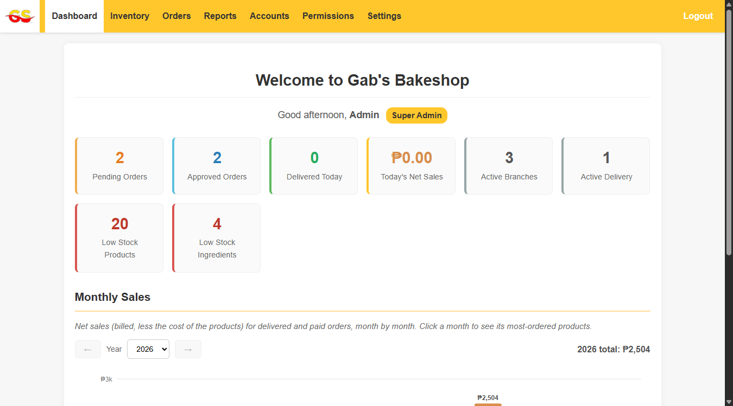
TC-02 - Invalid login [PASSED]
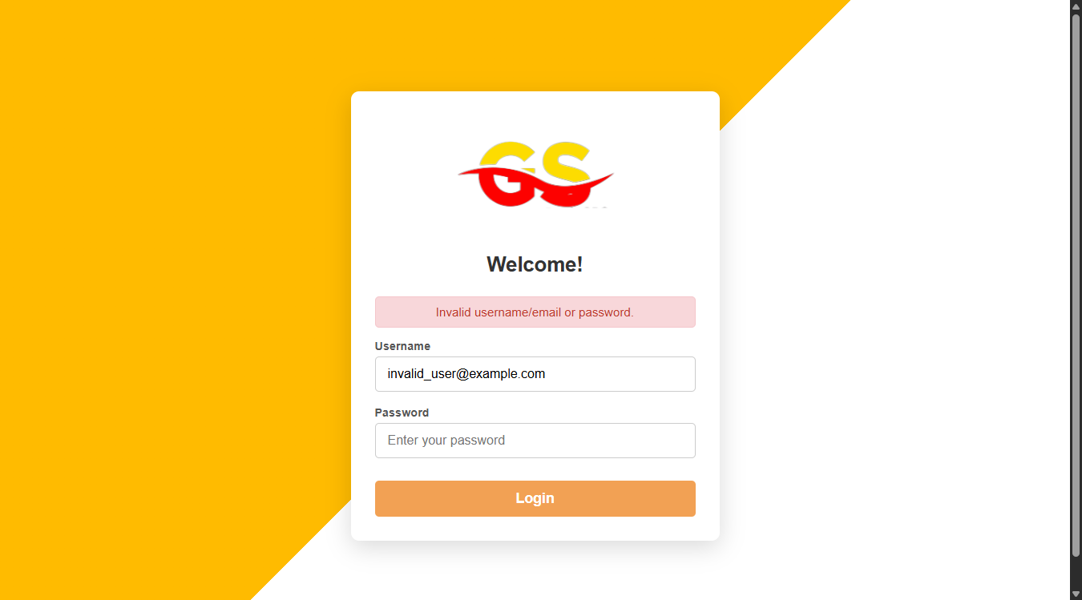
TC-03 - View dashboard [PASSED]
TC-04 - View inventory [PASSED]
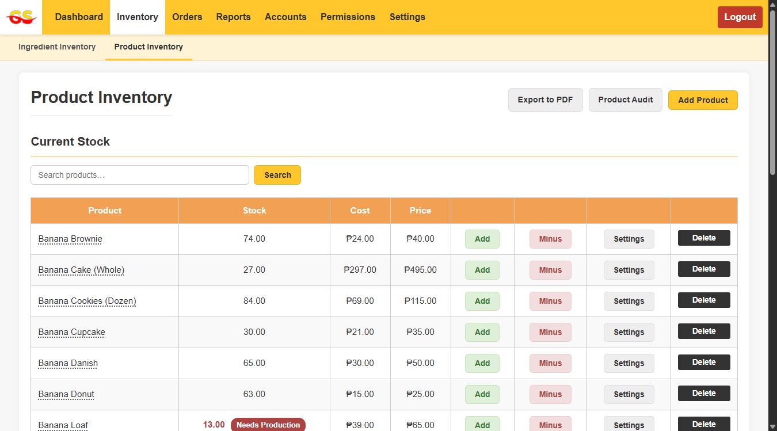
TC-05 - Search product [PASSED]
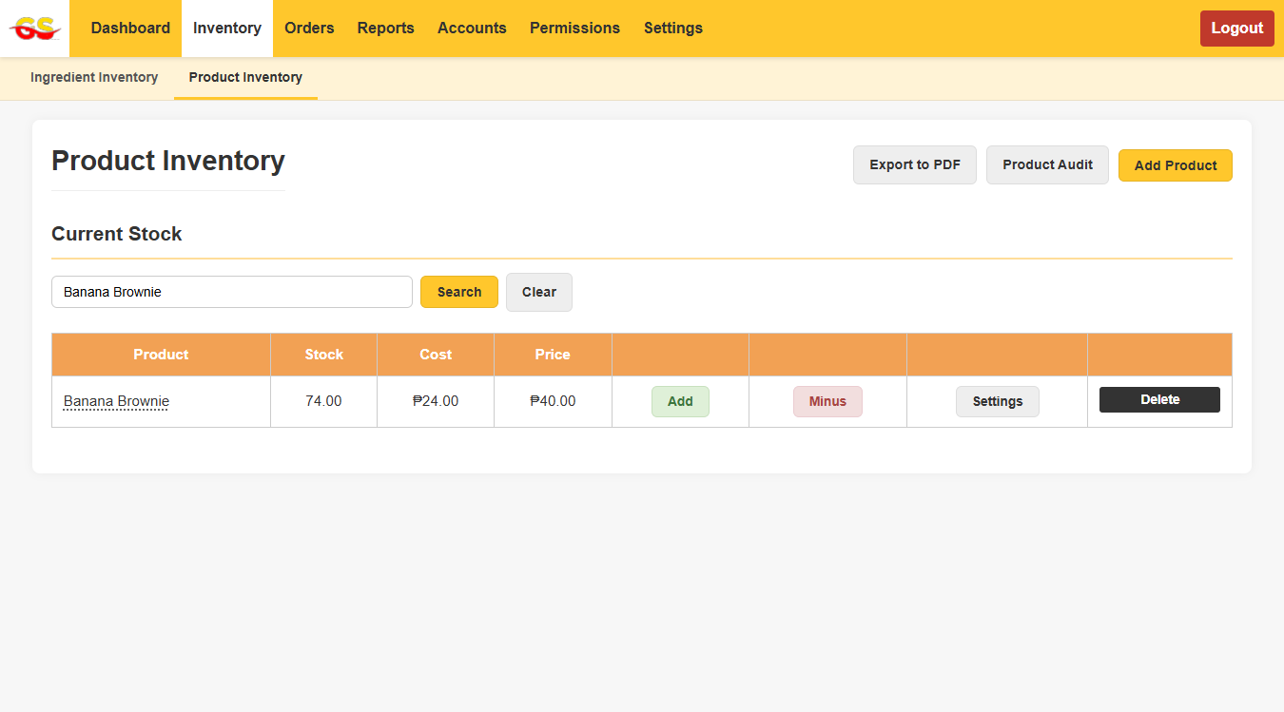
TC-06 - Verify that a branch owner can submit an order. [PASSED]
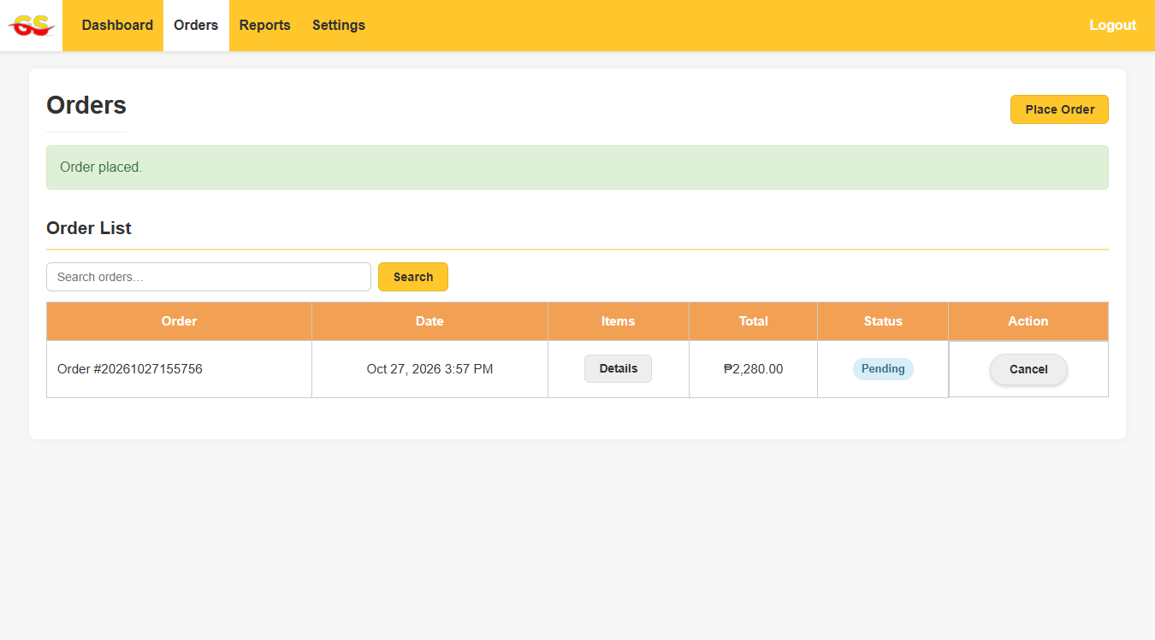
TC-07 - View order status [PASSED]
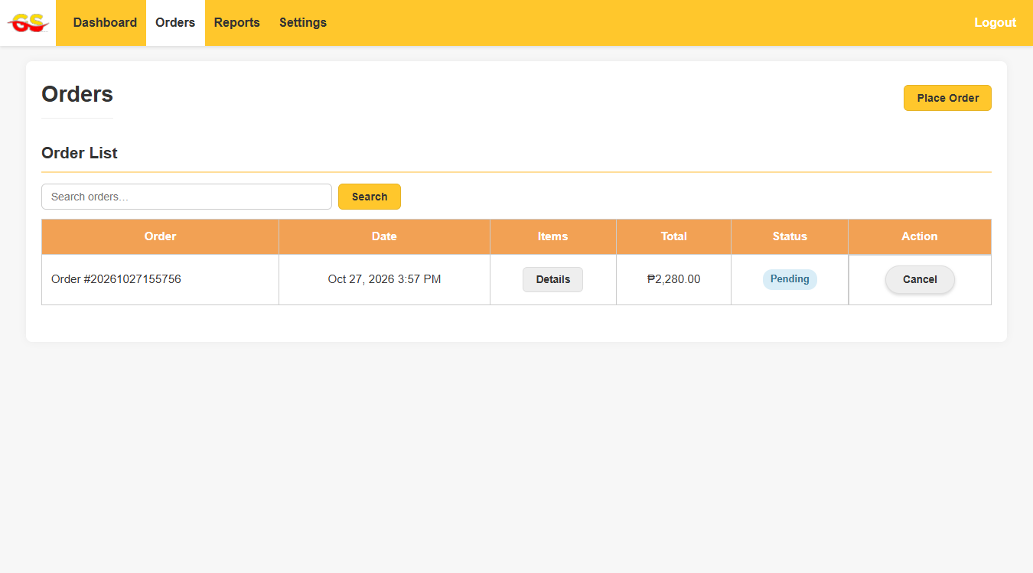
TC-08 - View delivery information [PASSED]
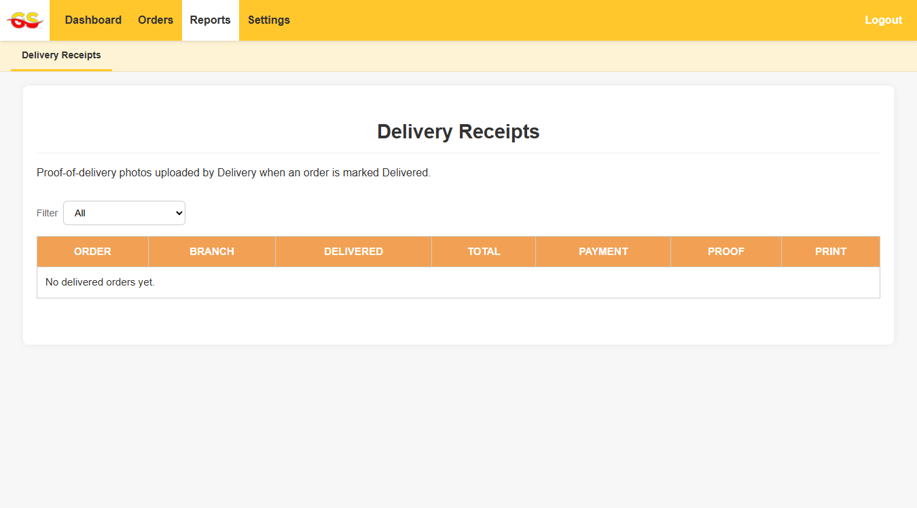
TC-09 - View reports [PASSED]
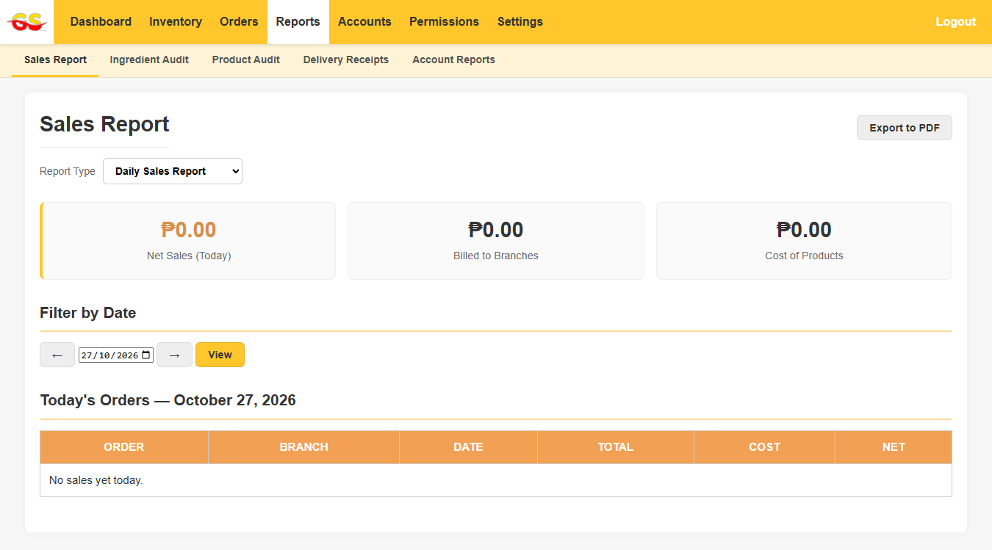
TC-10 - Verify that users can safely log out of the system. [PASSED]
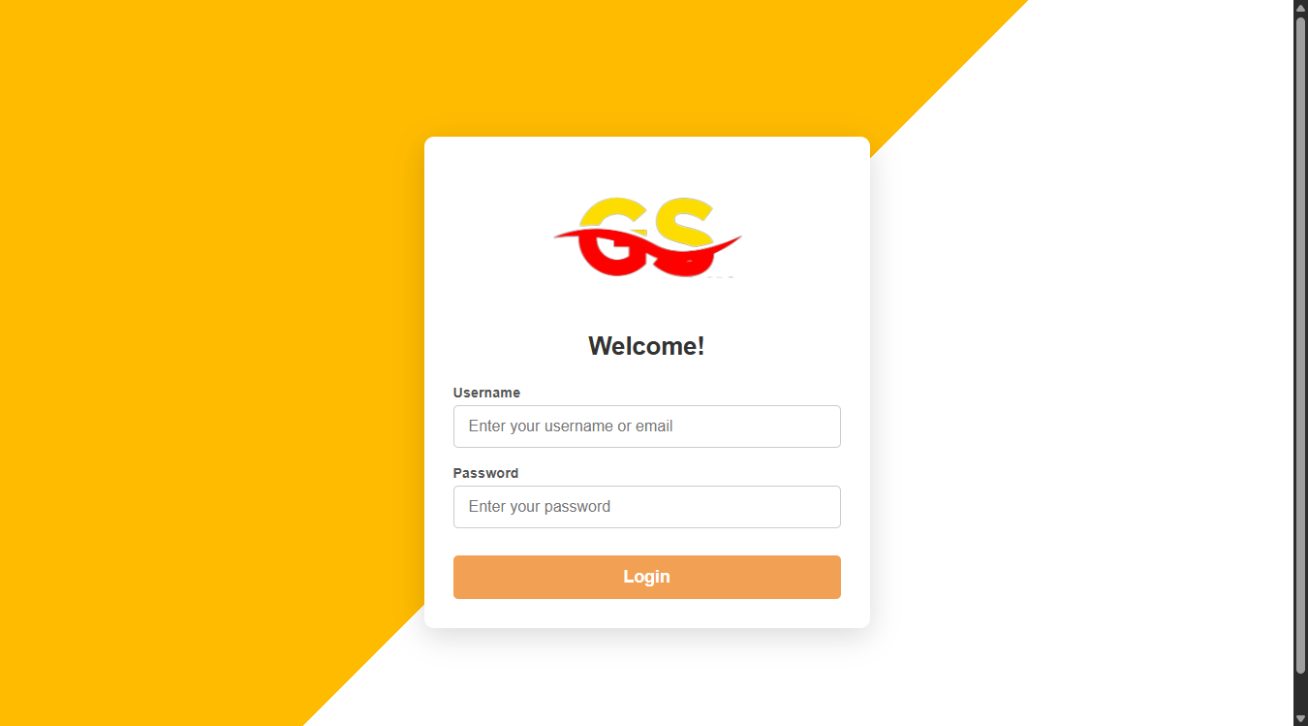
TC-11 - Submit empty data: add a product without a name. [PASSED]
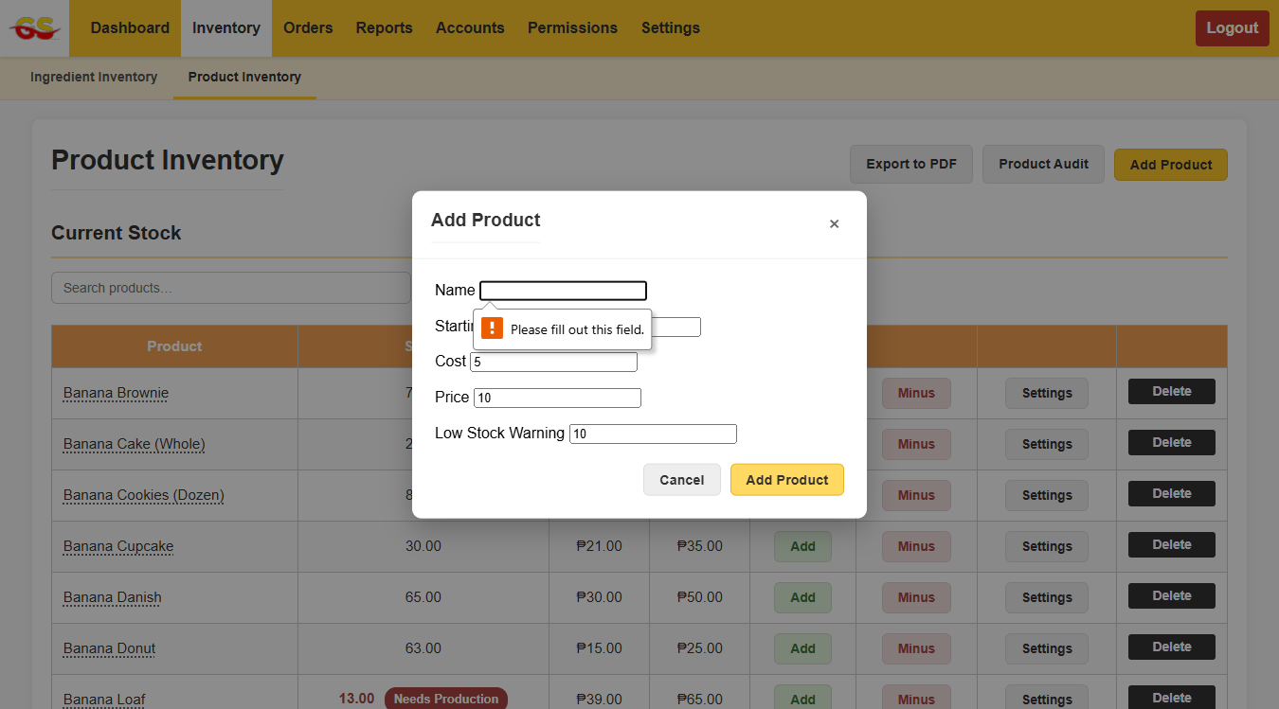
TC-12 - Add a record, verify it appears in the list, then delete it. [PASSED]
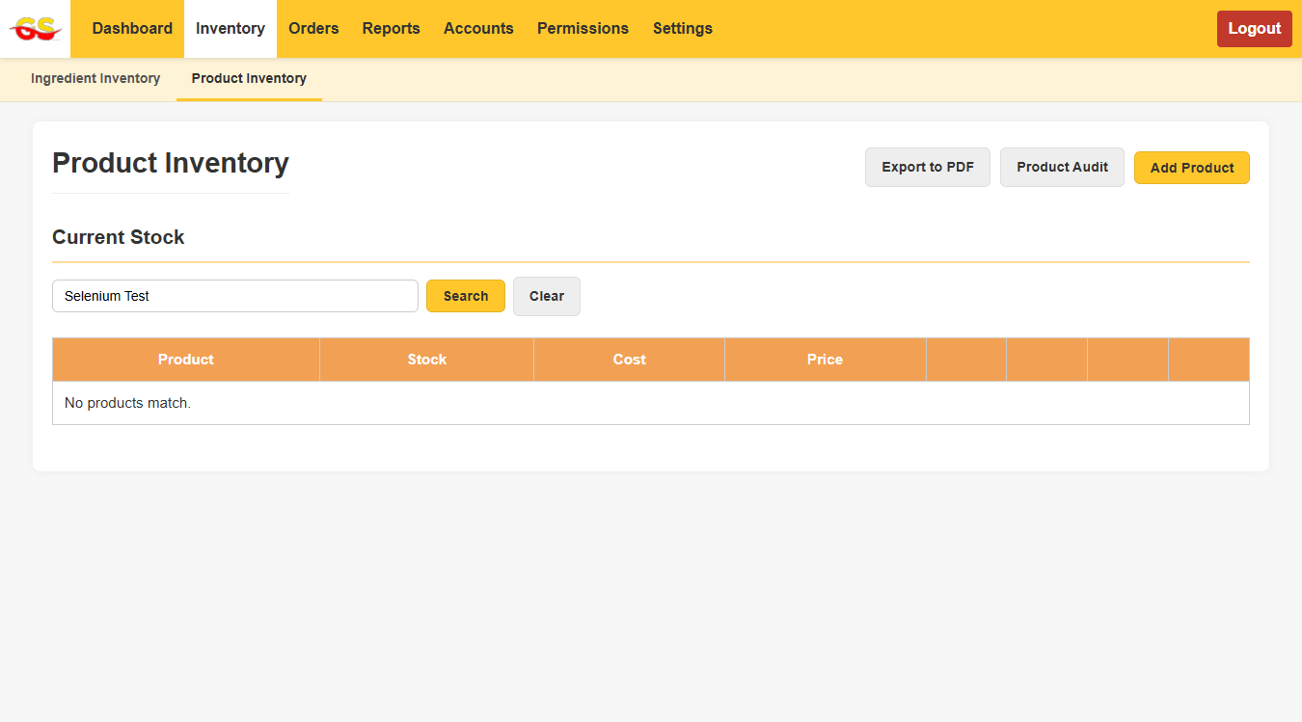

Test Summary
Test ID | Description | Result
TC-01 | Valid login | Passed
TC-02 | Invalid login | Passed
TC-03 | View dashboard | Passed
TC-04 | View inventory | Passed
TC-05 | Search product | Passed
TC-06 | Verify that a branch owner can submit an order. | Passed
TC-07 | View order status | Passed
TC-08 | View delivery information | Passed
TC-09 | View reports | Passed
TC-10 | Verify that users can safely log out of the system. | Passed
TC-11 | Submit empty data: add a product without a name. | Passed
TC-12 | Add a record, verify it appears in the list, then delete it. | Passed

Tests run: 12 Passed: 12 Failed: 0 Skipped: 0

Bugs and findings
- No functional defects were found by the 12 tests. These observations come from preparing the tests:
- Weak default administrator login. The local Super Admin account accepts a simple default password that is also written in legacy/fix_admin_password.php. Suggested fix: change the password, and delete that script and the legacy folder from the deployed site.
- TC-08 only verifies the Delivery Receipts page, because the test account has no delivered orders. Suggested fix: add a delivered sample order to the test data so the table row can be asserted.
- TC-06 and TC-12 change data (one order is placed; a product is added and then deleted). Run them on a test copy of the database.

AI Prompt Log
AI tool used: Claude (Anthropic). Every prompt in this session is listed below. Attach the exported chat history or screenshots of the full prompts and responses with this submission, as the practicum requires.
# | Prompt | What the AI did
1 | can you help me? i am backlogged with alot of work, can you do this for me please (attached: Selenium Final Activity.docx and Selenium WebDrivers.pdf) | Read both files, summarised the practicum requirements, and started building a Selenium test suite.
2 | ive turned on the local host of GABS project, ill give you access to the localhost version | Tested against the local copy instead of the live site.
3 | Access granted. Please move to C:\xampp\New folder\htdocs\GABS and continue. | Read the project's pages and menus, corrected the locators, ran all tests and filled in this report.

